Project Design Phase-II
Technology Stack (Architecture & Stack)

Date | 18 Feb 2026
Team ID | LTVIP2026TMIDS80588
Project Name | TransLingua: AI-Powered Multi-Language Translator
Maximum Marks | 4 Marks

Technical Architecture:
The Deliverable shall include the architectural diagram as below and the information as per the table1 & table 2
Example: Order processing during pandemics for offline mode
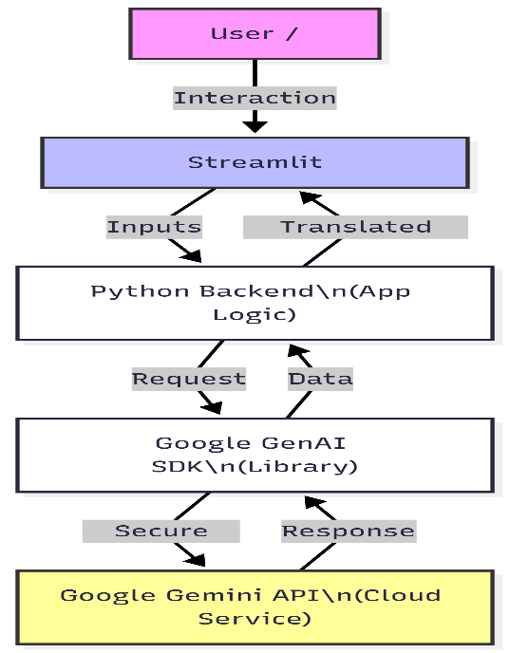
Guidelines:
Include all the processes (As an application logic / Technology Block)
Provide infrastructural demarcation (Local / Cloud)
Indicate external interfaces (third party API’s etc.)
Indicate Data Storage components / services
Indicate interface to machine learning models (if applicable)

Table-1 : Components & Technologies:
S.No | Component | Description | Technology
 | User Interface | Web-based dashboard with tabs for Docs, Camera, and Text. | Streamlit, Python
 | Application Logic-1 | Multimodal processing for Images and PDFs. | Python (google-genai SDK)
 | Application Logic-2 | Text extraction and context-aware translation. | Gemini 3 Flash Model
 | Application Logic-3 | Failover and error handling logic. | Python Exception Handling
 | Database | Temporary storage of session states. | Streamlit Session State
 | File Storage | Handling uploaded bytes (PDF/Images). | In-memory Buffer (io.BytesIO)
 | External API-1 | Core generative AI and vision services. | Google Gemini API
 | Machine Learning Model | Multimodal Large Language Model. | gemini-3-flash-preview
 | Infrastructure (Server / Cloud) | Application hosting and execution. | Local Server / Streamlit Cloud

Table-2: Application Characteristics:
S.No | Characteristics | Description | Technology
 | Open-Source Frameworks | Fast web app development for ML/Data apps. | Streamlit
 | Security Implementations | Environment-based API key management. | .env / Streamlit Secrets
 | Scalable Architecture | Serverless API consumption. | Micro-services (Google Cloud)
 | Availability | Automatic model switching if one is busy. | Multi-model Failover
 | Performance | Low-latency response using "Flash" models. | Gemini Flash Series

References:
https://c4model.com/
https://docs.streamlit.io
https://ai.google.dev/docs

